**My Chart**

A colourful live bar chart, with inputs for inserting its values.

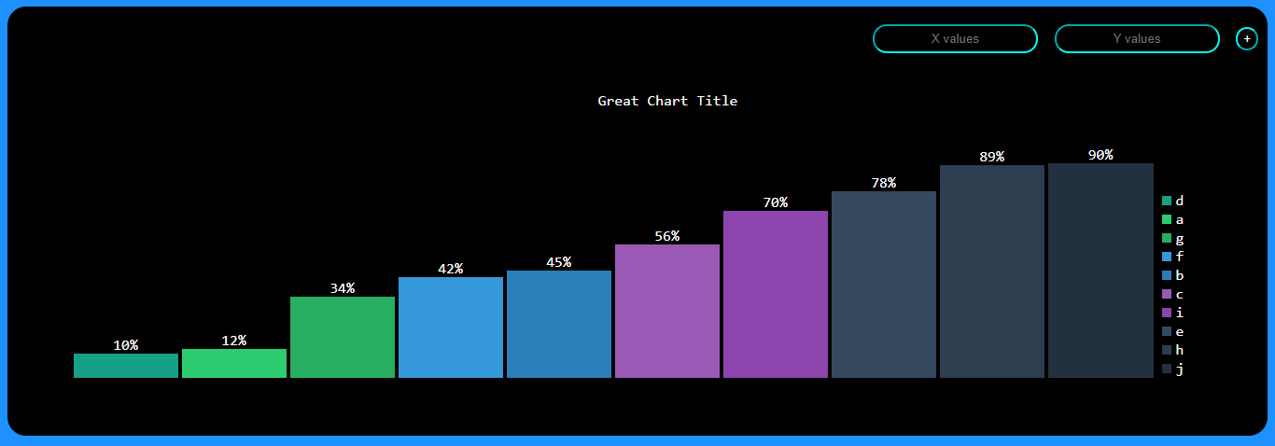

**Install**

Extract the files in the directory of the html file that will be using the component.

Paste the following inside the **<head>** tag of your html:

  <script src="./js/my-chart.js"></script>

  <script src="./js/chart-input.js"></script>

**Usage**

After that, you can use the newly defined tag **<my-chart>** wherever you want in your html.

  <my-chart title="Great Chart Title" prefix="%"></my-chart>

**Populating the chart**

In the upper right corner of the screen there are two inputs and one button:

* **X values** – (string): the values corresponding to the horizontal axis, generally strings. This is the name that will be displayed in the legend for identifying its Y.
* **Y values** – (positive number): the height of the bar that will be displayed in the chart for X.
* **+** - after filling in the inputs, press the button.

The chart updates with the new values in an **ascending order** for every new (X, Y) pair submitted.

A **legend** is displayed in the right side of the chart, based on the values introduced for X.

**Properties**

| **Name** | **Type** | **Default** | **Description** |
| --- | --- | --- | --- |
| title | string | Cool Colourful Barchart | The chart title that will be displayed. |
| prefix | string | % | The measurement that will be displayed on top of the bars, right next to the Y value. |

**Style**

The style is fully customizable. However, if you want to preserve the same style as shown in the picture, make sure you paste this in a **<style>** tag before closing the <body> tag:

html,

    body {

      background-color: dodgerblue;

      font-family: Consolas, monaco, monospace;

    }

    div#chart-container {

      align-items: center;

      align-self: center;

      background-color: black;

      text-align: center;

      padding-left: 5%;

      color: white;

      border-radius: 20px;

    }

    form#new-chart-form {

      float: right;

      padding: 10px;

      font-size: xx-large;

    }

    input {

      color: white;

      border-radius: 15px;

      border-width: 2px;

      text-align: center;

      background-color: black;

      height: 25px;

      border-color: cyan;

    }

    table {

      width: 100%;

      height: 400px;

    }

    .charttitle {

      text-align: center;

    }

    .bars td {

      vertical-align: bottom;

    }

    .bars div:hover {

      opacity: 0.6;

    }

    .legend {

      vertical-align: bottom;

      text-align: left;

    }

    .legbox {

      display: block;

      clear: both;

    }

    .xaxisname {

      margin: 5px;

      color: #fff;

      font-size: 77%;

      padding: 5px;

      float: left;

    }

    /*Flat UI colors*/

    .one {

      background: #16A085;

    }

    .two {

      background: #2ECC71;

    }

    .three {

      background: #27AE60;

    }

    .four {

      background: #3498DB;

    }

    .five {

      background: #2980B9;

    }

    .six {

      background: #9B59B6;

    }

    .seven {

      background: #8E44AD;

    }

    .eight {

      background: #34495E;

    }

    .nine {

      background: #2C3E50;

    }

    .ten {

      background: #22313f;

    }

    .eleven {

      background: #F1C40F;

    }

    .twelve {

      background: #F39C12;

    }

    .thirteen {

      background: #E67E22;

    }

    .fourteen {

      background: #D35400;

    }

    .fifteen {

      background: #E74C3C;

    }

    .sixteen {

      background: #C0392B;

    }